***Wireframe Documentation***

**Foreign Direct Investment Data Analysis**



**Revision Number - 1.2**

**Last Date of Revision - 20/05/2024**

**RISHI KALPA MUKHERJEE**

**Document Control**

|  |  |  |  |
| --- | --- | --- | --- |
| **Date** | **Version** | **Description** | **Author** |
| 30/04/2024 | 1.0 | Introduction, Problem Statement | Rishi Kalpa Mukherjee |
| 10/05/2024 | 1.1 | Dataset Information,  Architecture Design | Rishi Kalpa Mukherjee |
| 20/05/2024 | 1.2 | Final Revision | Rishi Kalpa Mukherjee |



As per our dataset is based on Foreign Direct Investment, we are supposed to analyse the historical data for the last 17 years from 2000-01 to 2016-17. The dataset contains sector and financial year wise data of FDI in India. We have performed the Exploratory Data Analysis and data visualization in Jupyter Notebook by coding necessary programming and created an intuitive and meaningful dashboard in Tableau.

GLIMPSE OF JUPYTER NOTEBOOK

First 10 Rows of Data:

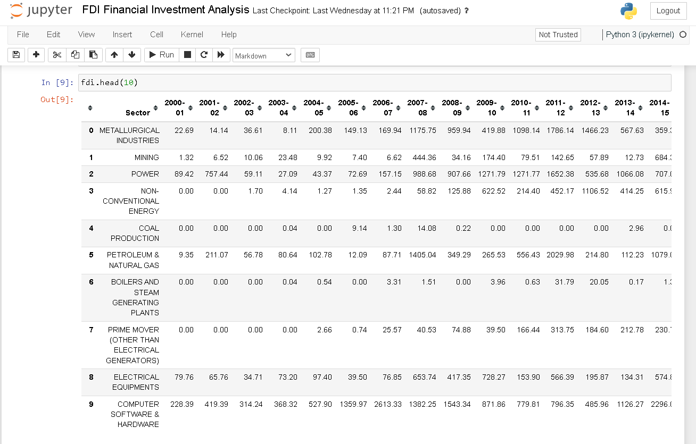

Descriptive Summary of Data:

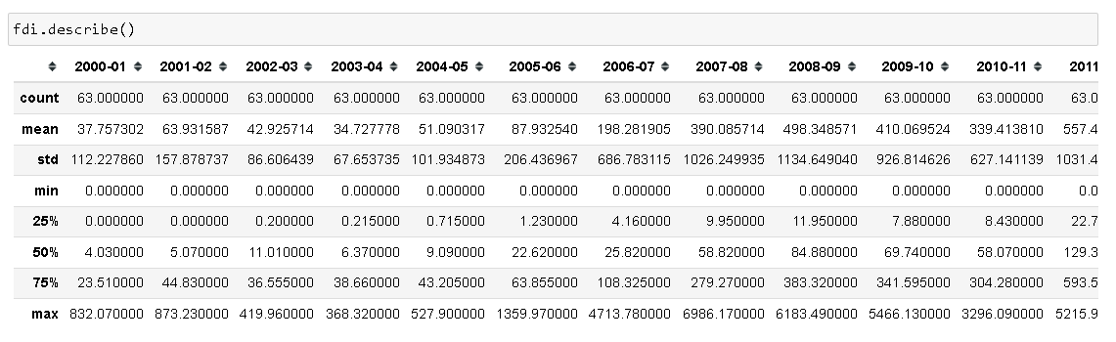

Histogram of Data

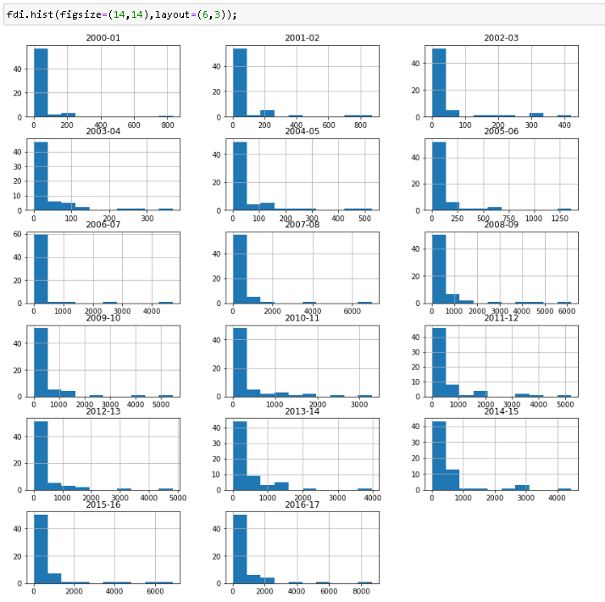

Boxplot:

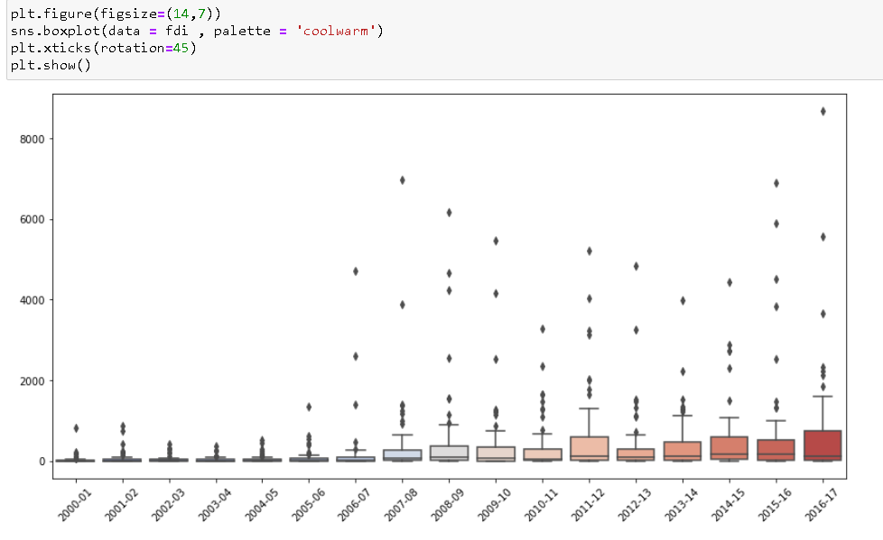

Heatmap: Checking the correlation between variables

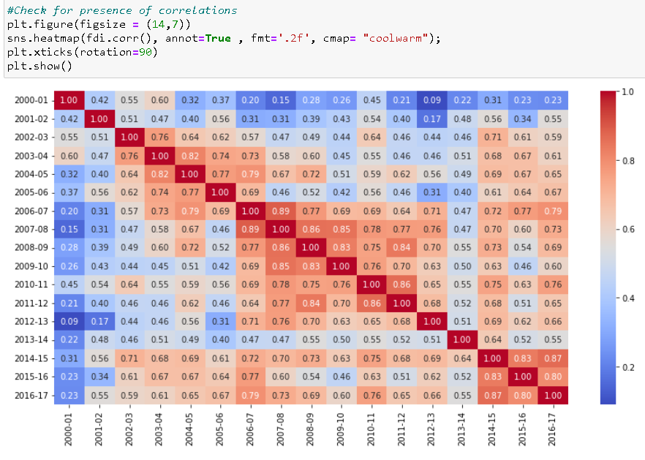

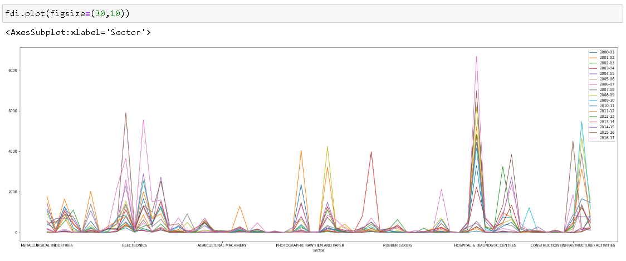

SECTOR WISE INVESTMENT ANALYSIS

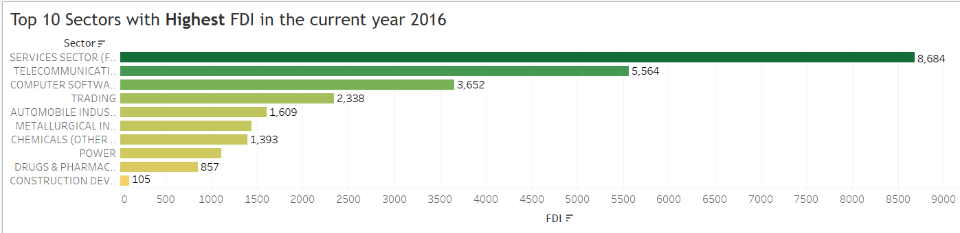

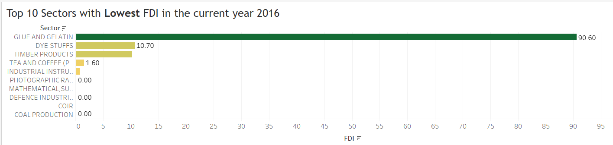

Services Sector being the highest FDI contributor with 8684 followed by Telecommunication with 5564. Computer Software stands as 3rd highest sector in terms of FDI for the year 2016. Glue and Gelatin being the lowest FDI contributor with 90.60 followed by Dye-Stuffs with 10 in the year 2016.

YEAR WISE INVESTMENT ANALYSIS

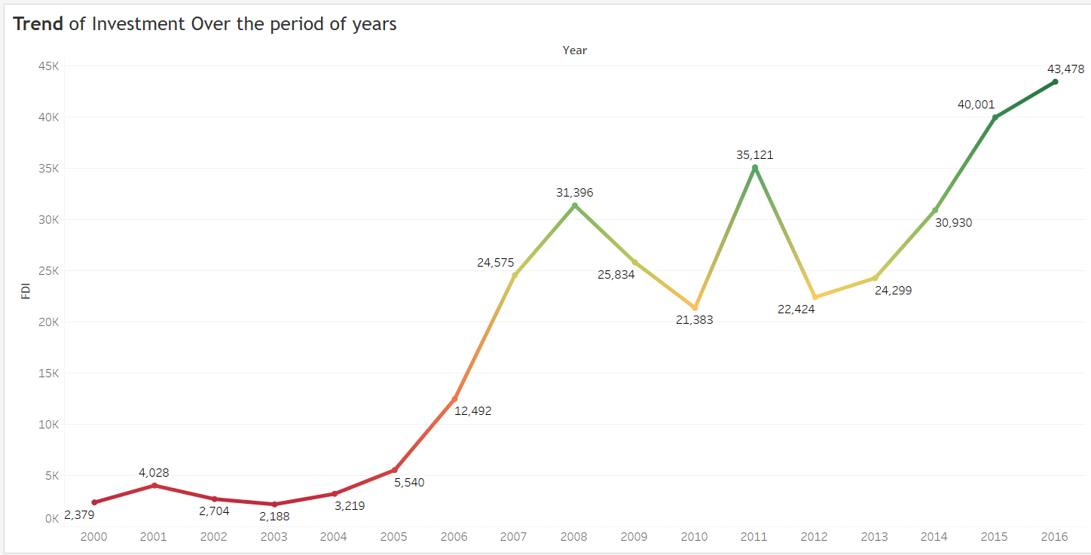

The above line chart shows the FDI India inflows of trends & patterns from 2000-01 to 2016-17. The line chart is in increasing trends from 2000 and the peak time is in the year 2008 which stands with 31396 where 2000 year which starts with 2379. In between there was a flip ups and downs and fluctuations between 2009 to 2012 and dip down flow analysed in the year 2010 and 2012. The highest FDI trend analysed in the year 2016 with 43478. The lowest FDI trends analysed in the year 2003 with 2188.

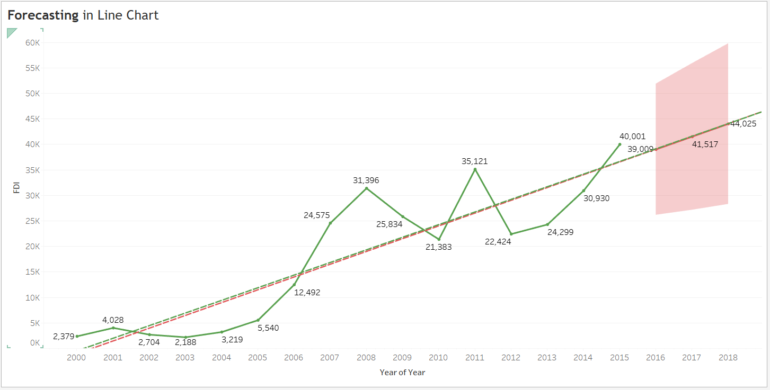

Forecasting of the line chart has been analysed and predicted for the years 2017 to 2018 which would stand ranging between 41517 and 44025. Actual and Estimate Forecast indicator has been utilized to see the trend line.

We designed and created dashboards by using standard visuals to interpret details:

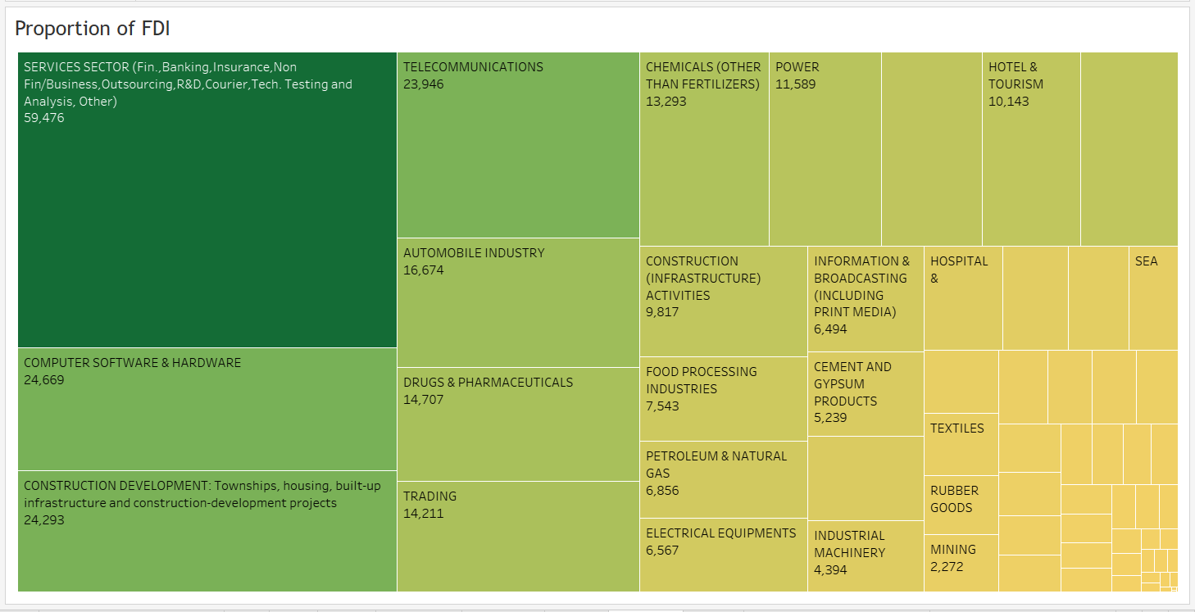

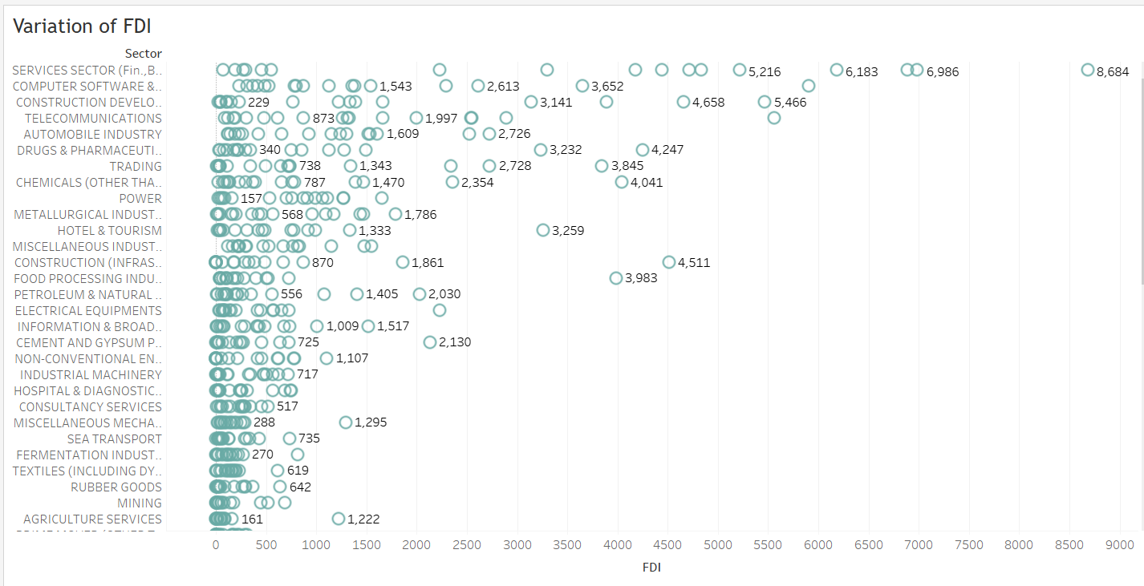

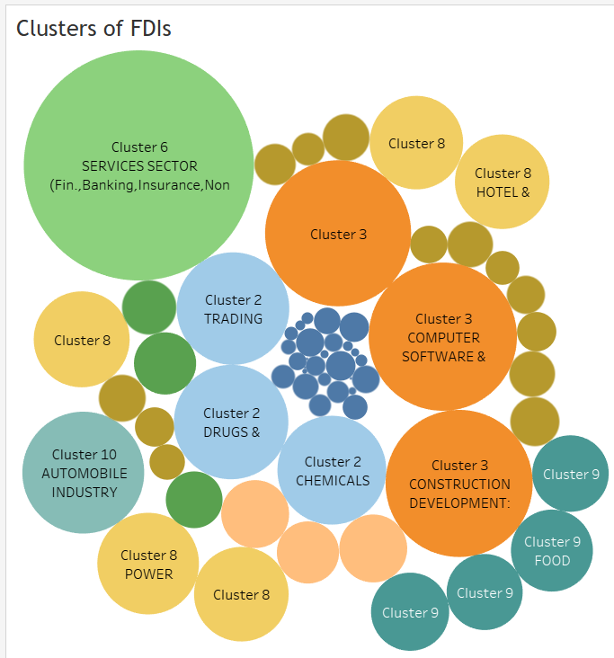

***End of Wireframe Documentation***

FDI Data Analysis